2) Using Form Tags,

2.1) Create a Login Form

2.2) Create a “Registration form” with the following fields

a) Name (Text field)

b) Password (password field)

c) E-mail id (text field)

d) Phone number (text field)

e) Sex (radio button)

f) Date of birth (3 select boxes)

g) Languages known (check boxes – English, Telugu, Hindi, Tamil)

h) Address (text area)

2.1)

<html>

<head>

<title> Login form </title>

<body bgcolor="lavender" >

<center>

<h1> LOGIN FORM </h1>

</center>

<form>

<label for="name">Enter username</label><br>

<input type="text" id="name" name="name"><br>

<label for="pass">Enter Password</label><br>

<input type="Password" id="pass" name="pass"><br>

<input type="submit" value="submit">

<input type="checkbox" checked="checked"> Remember me

<button type="button" class="cancelbtn"> Cancel</button>

Forgot <a href="#"> password? </a>

</form>

</body>

</html>

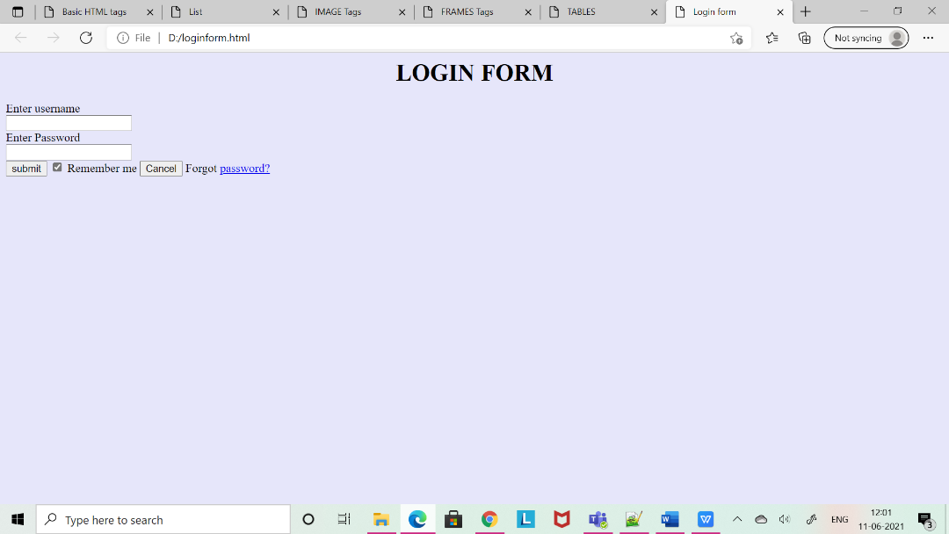

2.2)

<html>

<head>

<title> Registration Form </title>

</head>

<body>

<center>

<h1> REGISTRATION FORM </h1>

<form>

<table style="border:1px solid" bgcolor="lavender">

<tr>

<td><label>Name</label></td>

<td><input type="text" id="name" name="name" size="15"></td>

</tr>

<tr>

<td><label>Password</label></td>

<td><input type="Password"></td>

<td><input="Password" id="pass" name="pass"></td>

</tr>

<tr>

<td><label>E-Mail</label></td>

<td><input type="email" id="email" name="email"></td>

</tr>

<tr>

<td><label>Phone Number</label></td>

<td>

<input type="text" name="country code" value="+91" size="2"/>

<input type="text" name="phone" size="10"/>

</td>

</tr>

<tr>

<td><label>Gender</label></td><br>

<td>

<input type="radio" name="male"/>Male<br>

<input type="radio" name="female"/>Female<br>

<input type="radio" name="other"/>Other<br><br>

</td>

</tr>

<tr>

<td><label>Date of Birth</label></td>

<td><input type="date" name="dob"/></td>

</tr>

<tr>

<td><label>Languages Known</label></td><br>

<td>

<input type="checkbox" id="language1" name="language1" value="English">

<label for="language1"> English </label><br>

<input type="checkbox" id="language2" name="language2" value="Telugu">

<label for="language2"> Telugu </label><br>

<input type="checkbox" id="language3" name="language3" value="Hindi">

<label for="language3"> Hindi </label><br>

<input type="checkbox" id="language4" name="language4" value="Tamil">

<label for="language4"> Tamil </label><br><br>

</td>

</tr>

<tr>

<td><label>Address </label></td><br>

<td><textarea cols="80" rows="5" value="address"></textarea></td>

</tr>

<tr>

<td><center><button type="submit" class="registerbtn">Register</button></center></td>

</tr>

<tr>

<td><center><button type="reset" class="resetbn">Reset</button></center></td>

</center>

</tr>

</center>

